实验二 运算器实验

74LS181逻辑功能表

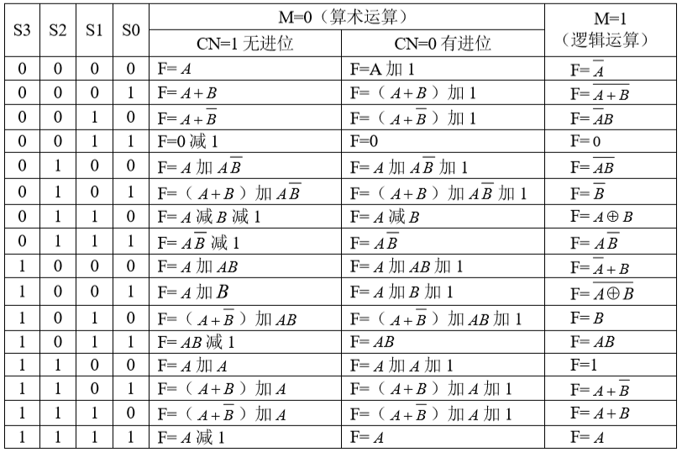

实验结果记录表

|  |  |  |  |  |  |  |  |  |  |  |
| --- | --- | --- | --- | --- | --- | --- | --- | --- | --- | --- |
| DRA | DRB | S3 | S2 | S1 | S0 | M=0（算术运算） | | 标志位 CF/ZF/SF | | M=1  逻辑运算 |
| CN=1  无进位 | CN=0  有进位 | CN=1  无进位 | CN=0  有进位 |
| 0xAA | 0x55 | 0 | 0 | 0 | 0 | F= | F= |  |  | F= |
|  |  | 0 | 0 | 0 | 1 | F= | F= |  |  | F= |
|  |  | 0 | 0 | 1 | 0 | F= | F= |  |  | F= |
|  |  | 0 | 0 | 1 | 1 | F= | F= |  |  | F= |
|  |  | 0 | 1 | 0 | 0 | F= | F= |  |  | F= |
|  |  | 0 | 1 | 0 | 1 | F= | F= |  |  | F= |
|  |  | 0 | 1 | 1 | 0 | F= | F= |  |  | F= |
|  |  | 0 | 1 | 1 | 1 | F= | F= |  |  | F= |
|  |  | 1 | 0 | 0 | 0 | F= | F= |  |  | F= |
|  |  | 1 | 0 | 0 | 1 | F= | F= |  |  | F= |
|  |  | 1 | 0 | 1 | 0 | F= | F= |  |  | F= |
|  |  | 1 | 0 | 1 | 1 | F= | F= |  |  | F= |
|  |  | 1 | 1 | 0 | 0 | F= | F= |  |  | F= |
|  |  | 1 | 1 | 0 | 1 | F= | F= |  |  | F= |
|  |  | 1 | 1 | 1 | 0 | F= | F= |  |  | F= |
|  |  | 1 | 1 | 1 | 1 | F= | F= |  |  | F= |